NASA Space Probe Touches the Sun
Space probes proliferate the Solar System, exploring various incredible areas. However, an area of the Solar System that has gone largely untapped is the Solar System’s own namesake — the Sun. That is, up until recently. A new NASA space probe, dubbed the “Parker Probe”, has just touched the Sun’s corona. This is truly a feat of science and engineering.
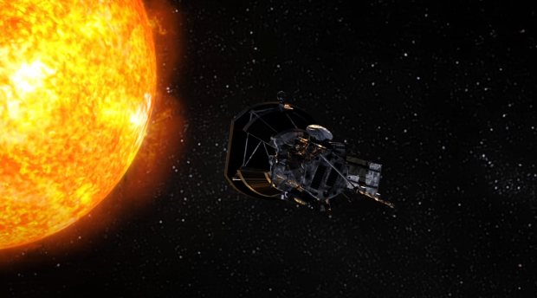
How did NASA's probe touch the Sun without melting? NASA answers | TweakTown
The reason that the Parker Probe can withstand the Sun’s heat has everything to do with its design. On the most fundamental levels, the Parker Probe’s technology is engineered for the task. It is retrofitted with white, reflective solar shields, which reorient themselves to redirect the Sun’s heat (1). The orientation of the solar shield is monitored by an on-board solar sensor, which can detect the direction of the Sun’s energy. It accomplishes this by measuring photon wavelengths — the intensity of light (2).
In addition to its solar shielding, the probe has a water-cooling system and radiator (1). These do a lot of heavy lifting in terms of keeping the system from overheating. Nevertheless, the conditions that the Parker Probe must endure are quite extreme. Its sensors, which have minimal shielding, endure temperatures of 1,000 degrees Celsius (2). To reduce damage of the machine, it is constructed of high-grade materials with high melting points: “tungsten, niobium, molybdenum, and sapphire” (2).
The mission of the Parker Probe is to gather new data on the behavior within the Sun’s corona. This area of the Sun is dominated by magnetic fields and solar winds, which can impact our electronics on Earth. Thus far, the probe has been able to determine patterns in solar winds, and where they originate (3). However, another thing the probe is trying to uncover is why the Sun’s atmosphere is so much hotter than its surface (2). It has been studying the boundary between the solar atmosphere and solar winds and found them to be “wrinkled rather than smooth” (3). NASA appears to be happy with their results, reporting, “We see evidence of being in the corona in magnetic field data, solar wind data, and visually in images. We can actually see the spacecraft flying through coronal structures that can be observed during a total solar eclipse” (2).
The Parker Probe is yet another feat of NASA innovation that stands as a reminder of what can be achieved through technology. The science it is uncovering is helping massively in the construction of better scientific models for star behavior. Hopefully the Parker Probe will continue to make new findings and give us a clearer picture of our universe.
Sources:
- How did NASA's probe touch the Sun without melting? NASA answers | TweakTown
- Spacecraft Enters the Sun’s Blistering Hot Corona for the First Time in History (scitechdaily.com)
- NASA Probe 'Touches the Sun', Realizing a 63-Year Ambition (ign.com)

